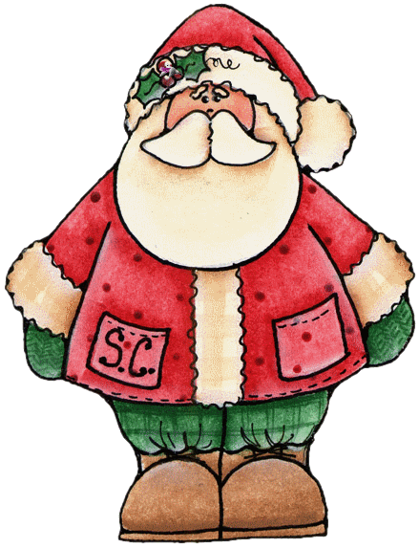
2020 Athens North Pole Stroll
Hosted by Athens-Limestone County Tourism Association
Big Spring Park Athens, AL
What are the guidelines for decorating my tree?
IMPORTANT: Please secure all decorations to your tree using pipe cleaners, small zip ties, or other strings/ties to prevent hook ornaments from falling off in the wind and weather.
- Decorators must provide their own decorations and lighting
- Decorators must use Solar Powered LED outdoor lights only. We reserve the right to remove any lights that are not Solar Powered LED. We recommend using 4-5 strings of LED outdoor lights per tree for best appearance.
- Edible items use to decorate are prohibited including but not limited to candy canes, popcorn, and birdseed.
- Athens North Pole Stroll will provide each sponsor/decorator with one live Christmas Tree and signage listing sponsor/decorator. Do not remove the sign when un-decorating, please leave the sign for reuse. If you took your sign during the previous year, please return it for reuse.
- Athens Police Department will increase patrols in the park during the duration of the event.
- Standard trees are approximately 6’ tall.
- Please, no offensive or inappropriate décor. We reserve the right to remove offensive displays.
- Please check your tree and decorations regularly – especially after windy days and rainy days. We are not responsible for the loss of any decorations.
- Please be available and adhere to setup and takedown dates. It is crucial the park be restored to its natural order as quickly as possible.
What are the guidelines for decorating my tree?
Branded material from your company, organization, or group is welcome. However, we request you refrain from using political or inflammatory images or materials as decorations. No matter what, get creative and have fun! We only ask you to keep it appropriate for all ages.
What are some things I should bring to decorate my tree?
- Weather-proof, non-breakable decorations
- If using paper or pictures – please laminate your images
- Scotch Guard to prevent mold and mildew on ribbons and fabric
- Small step ladder
- Solar-powered LED outdoor lights (4-5 strings but the more, the better)
- Do not use water soluble glue on ornaments
- Bread ties, zip ties, pipe cleaners, wires, or other similar items to secure decorations
Dates to make note of:
  - November 16, 2020 – Last Day to Buy Trees
  - November 22-December 2, 2020 – Decorating Days
  - December 3, 2020 -- Athens-Limestone Christmas Parade
  - December 27, 2020 - Jan 3, 2021 – Take down days

